***Eating with our Eyes***

***Design and Technologies – Food Specialisation***

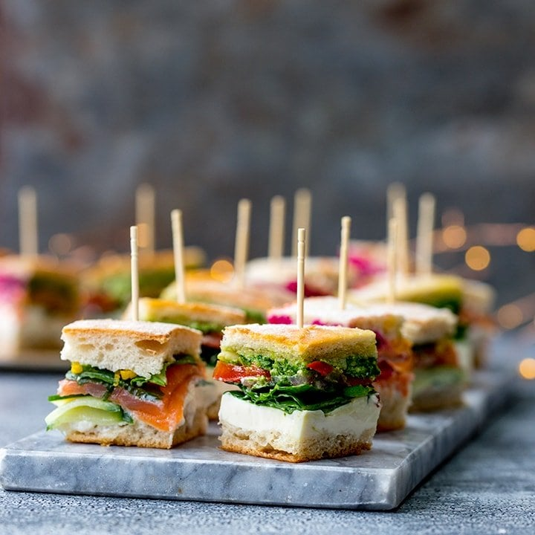

**Year 8FST**

**Term One, 2023**

**Name: ___________________________**

The phrase ‘We eat with our eyes’ describes our visual reaction to food. Its appearance is usually the first impression we experience, affecting the way we perceive and react to the food. The sight of attractive food prepares our bodies to digest it by activating our digestive system. Colours affect the way we perceive food: by the colour, we can see if it is ripe, and can predict how it will taste and if it is healthy. It can even impact how full you feel and how much you eat. This is why presentation is important, especially when producing food for others.

|  |
| --- |
| **The challenge**  If colour is a key principle in food presentation, how can food be visually appealing if it is only one colour? |

In teams, you are required work collaboratively to design, plan, produce, and present a visually appealing savoury finger food for a party using only one colour. Take photos of the equipment and processes you use. Take a photo of your finger food presented for serving. (Optional: convert photos into a movie). Submit these to your teacher for assessment.

**Constraints**

You must:

* work collaboratively to plan a finger food product
* produce and present the design in one lesson
* take photos of the equipment selected and used
* take photos of the processes selected and used
* take a photo of your overall presentation.

The design must:

* be a sweet or savoury finger food
* have at least three ingredients
* be only one colour, without using food colouring
* be visually appealing.
* Cost less than $0.60 a serve

**Considerations**

* Are the ingredients readily available and reasonably priced?
* Do you know the preparation processes?
* Do you have the necessary skills?
* Do you know how to appropriately and safely use the equipment required?
* Can the product be produced within one practical lesson timeframe?

To achieve the best grade possible, make sure you understand all the outcomes that will be assessed. There are two Strands assessed in Year 8 Food Technology these have several sub-strands, which will also be assessed. These are listed below:

* **Knowledge and Understandings**
* Technologies in Society
* Technologies Contexts: Food Specialisations
* **Process and Production Skills**
  + Investigating and Defining
  + Designing
  + Producing and Implementing
  + Collaborating and Managing
  + Evaluating

**Please use only a black pen, blue pen or a lead pencil to complete this task booklet**

**Marking Guide**

|  |  |  |  |  |  |  |
| --- | --- | --- | --- | --- | --- | --- |
| **ASPECT**  **CONTENT** | **Specific Task Criteria** | **A**  **(10 marks)** | **B**  **(8 marks)** | **C**  **(6 marks)** | **D**  **(4 marks)** | **E**  **(2 marks)** |
| **Investigate and Define** | Investigate single-coloured foods | Comprehensive; | Insightful; Effective; Informed | Sound; At Standard | Partial | Fragmented |
|  | **Specific Task Criteria** | **A**  **(10 marks)** | **B**  **(8 marks)** | **C**  **(6 marks)** | **D**  **(4 marks)** | **E**  **(2 marks)** |
| **Design** | Generate THREE possible recipes for your task; state the good (pros) and bad (cons). | Comprehensive; | Insightful; Effective; Informed | Sound; At Standard | Partial | Fragmented |
|  | **Specific Task Criteria** | **A**  **(30 marks)** | **B**  **(24 marks)** | **C**  **(18 marks)** | **D**  **(12 marks)** | **E**  **(6 marks)** |
| **Producing and implementing** | Time management, Ability to problem solve, Personal hygiene, Food safety,  Food preparation skills.  Appropriate selection of equipment and techniques to prepare dish.  Unit cleaned to specified standards.  Rostered duty completed  Completed a food order, costing, method and special equipment | Comprehensive; | Insightful; Effective; Informed | Sound; At Standard | Partial | Fragmented |
|  | **Specific Task Criteria** | **A**  **(20 marks)** | **B**  **(16 marks)** | **C**  **(12 marks)** | **D**  **(8 marks)** | **E**  **(4 marks)** |
| **Collaborating and managing** | Demonstrates team skills and works cooperatively as a team member to complete duties.  Willingly assists others. | Comprehensive; | Insightful; Effective; Informed | Sound; At Standard | Partial | Fragmented |
|  | **Specific Task Criteria** | **A**  **(10 marks)** | **B**  **(8 marks)** | **C**  **(6 marks)** | **D**  **(4 marks)** | **E**  **(2 marks)** |
| **Evaluating** | Self-evaluation | Comprehensive; | Insightful; Effective; Informed | Sound; At Standard | Partial | Fragmented |
| **Knowledge and understanding** | | | | | | |
|  | **Specific Task Criteria** | **A**  **(10 marks)** | **B**  **(8 marks)** | **C**  **(6 marks)** | **D**  **(4 marks)** | **E**  **(2 marks)** |
| **Tech in Society** | Select your favourite recipe option and state why you have chosen this option; Does your selected recipe meet the requirements of the healthy eating pyramid? Why or why not?; List one safety and one hygiene aspect you need to consider when making your recipe; Place the ingredients into the correct section of the Healthy Eating Pyramid: (include quantities) | Comprehensive; | Insightful; Effective; Informed | Sound; At Standard | Partial | Fragmented |
| **Food specialisation** | 1. *Healthy Eating Pyramid* 2. What is the Healthy Eating Pyramid?; Explain why it is important to use the Healthy Eating Pyramid as a guide to your food choices; Which section should they come from?; List some of the consequences for our society if many people were unhealthy; Do you think as a society we should be concerned about others eating in a healthy way? Justify your response. | Comprehensive; | Insightful; Effective; Informed | Sound; At Standard | Partial | Fragmented |

|  |  |
| --- | --- |
| **FOOD SPECIALISATION: Healthy Eating Pyramid** |  |
| 1. What is the Healthy Eating Pyramid? __ /1 |
|  |
|  |
|  |
|  |
| *http://www.nutritionaustralia.org/national/resource/healthy-eating-pyramid* |
| 1. Explain why it is important to use the Healthy Eating Pyramid as a guide to your food choices.   __ /1 | |
|  | |
|  | |
|  | |
|  | |
| Different ingredients can be added to increase the nutritional value of a basic recipe.   1. Which section should they come from? __ /2 | |
|  | |
| 1. List some of the consequences for our society if many people were unhealthy. __ /4 | |
|  | |
|  | |
|  | |
|  | |
| 1. Do you think as a society we should be concerned about others eating in a healthy way? Justify your response. __ /2 | |
|  | |
|  | |
|  | |
| **____ /10** | |

**INVESTIGATE AND DEFINE**

* + - 1. Investigate foods of different colours and list as many as you can in the categories below. This will help when you design your single-coloured finger food.

|  |  |  |  |  |  |  |  |  |
| --- | --- | --- | --- | --- | --- | --- | --- | --- |
| **Red foods** | **Yellow foods** | **Orange foods** | **Green foods** | **White foods** | **Brown foods** | **Black foods** | **Blue foods** | **Purple foods** |
| e.g. red quandong | e.g. Banana |  |  |  |  |  | e.g. blue quandong | **__ /10** |

**DESIGN**

Share your single-coloured finger food ideas with your team members. Sketchthree possible finger foods your team could make. Annotate each ingredient and visual presentation elements. __ /6

|  |  |  |
| --- | --- | --- |
| **Design 1** | **Design 3** | **Design 3** |

Evaluate each design idea using the given constraints. List any other considerations the design meets.

|  |  |  |
| --- | --- | --- |
| **PRO:**  **CON:** | **PRO:**  **CON:** | **PRO:**  **CON:** |

* + - 1. Based on your evaluations, select the **most suitable** finger food design. Why have you chosen this recipe? __ /4

|  |  |
| --- | --- |
|  |  |
|  |
|  |
|  |
|  |
|  |
|  |
|  |  |
|  |

**__ /10**

1. Does your selected recipe meet the requirements of the healthy eating pyramid? Why or why not? If not, what improvements can you make to ensure it does?

|  |
| --- |
|  |
|  |
|  |
| __ /4 |

1. List one safety and one hygiene aspect you need to consider when making your recipe.

|  |
| --- |
|  |
| __ /2 |

1. Place your ingredients into the correct sections of the Healthy Eating Pyramid. Ensure you include quantities.

__ /4

**__ /10**

**PRODUCE AND IMPLEMENT**

Create a recipe card to support your recipe, researching the ingredients using Coles online, to cost. __ /20

|  |  |  |  |  |  |  |  |  |  |  |  |  |  |
| --- | --- | --- | --- | --- | --- | --- | --- | --- | --- | --- | --- | --- | --- |
| **RECIPE CARD** | | | | | | | | | | | | | |
| RECIPE NAME: | | | | | | | | | | PREP TIME: | | | |
| PORTIONS: | | | COST PER SERVING: $ | | | | | | | COOKING TIME: | | | |
| **INGREDIENTS:** | | | | | **QUANTITY:** | | | **INGREDIENTS:** | | | | **QUANTITY:** | |
|  | | | | |  | | |  | | | |  | |
|  | | | | |  | | |  | | | |  | |
|  | | | | |  | | |  | | | |  | |
|  | | | | |  | | |  | | | |  | |
|  | | | | |  | | |  | | | |  | |
|  | | | | |  | | |  | | | |  | |
|  | | | | |  | | |  | | | |  | |
|  | | | | |  | | |  | | | |  | |
|  | | | | |  | | |  | | | |  | |
|  | | | | |  | | |  | | | |  | |
| EQUIPMENT: | | | | | | | | | | | | | |
|  | | | | | | | | | | | | | |
| RECIPE METHOD: | | | | | | | | | | | | | |
|  | | | | | | | | | | | | | |
| **COST ANALYSIS** | | | | | | | | | | | |
| **INGREDIENTS:** | | | **Item Cost** | | | **Quantity Purchased** | | **Recipe Amount**  **(Portion required)** | | **Final Cost** | |
|  | | |  | | |  | |  | |  | |
|  | | |  | | |  | |  | |  | |
|  | | |  | | |  | |  | |  | |
|  | | |  | | |  | |  | |  | |
|  | | |  | | |  | |  | |  | |
|  | | |  | | |  | |  | |  | |
|  | | |  | | |  | |  | |  | |
|  | | |  | | |  | |  | |  | |
|  | | |  | | |  | |  | |  | |
|  | | |  | | |  | |  | |  | |
|  | | |  | | |  | |  | |  | |
|  | | |  | | |  | |  | |  | |
|  | | |  | | |  | |  | |  | |
|  | | |  | | |  | |  | |  | |
|  | | |  | | |  | |  | |  | |
|  | | |  | | |  | |  | |  | |
|  | | |  | | |  | |  | |  | |
|  | | |  | | |  | |  | |  | |
|  | | |  | | |  | |  | |  | |
|  | | |  | | |  | |  | |  | |
|  | | |  | | |  | |  | |  | |
|  | | |  | | |  | |  | |  | |
|  | | |  | | |  | |  | |  | |
|  | | |  | | |  | |  | |  | |
|  | | |  | | |  | |  | |  | |
|  | | |  | | |  | |  | |  | |
|  | | |  | | |  | |  | |  | |
|  | | |  | | | |  | | | **Total:** | |  | |
|  | | |  | | | |  | | | **Serves:** | |  | |
|  | | |  | | | |  | | | **Cost per serve:** | |  | |

Create a workflow plan to ensure you are able to complete your task in the allocated time. __ /10

|  |  |  |  |
| --- | --- | --- | --- |
| **WORKFLOW PLAN – FUNCTION:** | **DATE:** | |  |
| **DISH:** | | | |
| **NAME/S:** | | | |
| **STEPS:** | **TIME:** | **INGREDIENTS:** | **EQUIPMENT NEEDED:** |
|  |  |  |  |
|  |  |  |  |
|  |  |  |  |
|  |  |  |  |
|  |  |  |  |
|  |  |  |  |
|  |  |  |  |
|  |  |  |  |
|  |  |  |  |
|  |  |  |  |
|  |  |  |  |
|  |  |  |  |
|  |  |  |  |
|  |  |  |  |
|  |  |  |  |
|  |  |  |  |
|  |  |  |  |
|  |  |  |  |
|  |  |  |  |
|  |  |  |  |
| **Notes:** |  |  |  |
|  | | | | |
|  | | | | |
|  | | | | |

**EVALUATION**

|  |  |  |
| --- | --- | --- |
| 1. Give yourself a score out of 3 (1 lowest and 3 highest), justify your score. __ /3 | | |
|  | Score | Provide reasons for your decision |
| Teamwork skills |  |  |
|  |
| Organisation of work |  |  |
|  |
| Food orders |  |  |
|  |
| Recipe plans |  |  |
|  |
| Safe food handling practices |  |  |
|  |
| Food processing techniques |  |  |
|  |
| 1. Did you experience any minor problems or complications when preparing and cooking this food and if so, what were they and how did you overcome them? __ /1 | | |
|  | | |
|  | | |
|  | | |
|  | | |
| 1. What was most challenging part of the task? __ /1 | | |
|  | | |
|  | | |
|  | | |
| 1. If you were to complete this task again, what could be done differently to improve the outcome? __ /2 | | |
|  | | |
|  | | |
|  | | |
| 1. What was the most interesting fact you learnt whilst completing your research? __ /1 | | |
|  | | |
|  | | |
|  | | |
| 1. How does your snack rate in nutritional value? __ /2 | | |
|  | | |
|  | | |

**__ /10**